PICKLEBALL ?? OR TENNIS ??
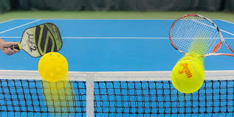
OPEN DAY
COME AND TRY COME AND PLAY

WHERE: NOLLAMARA TENNIS CLUB, KINDRA WAY, NOLLAMARA

WHEN: SUNDAY 3rd OCTOBER, 10am – 3pm

WHO: EVERYONE FROM PRIMARY SCHOOL TO GRANDPARENTS

HOW MUCH: FREE

Pickleball is the fastest growing sport in the world!! Played on a court less than half the size of a tennis court. It is suited to all ages. Games are short, underarm serves standard, lots of laughs-truly a family game. Equipment will be provided.
Tennis will be on the grass courts, with junior red ball courts available.
Sausage sizzle lunch available 12pm-1pm with halal ($2.50) vegetarian ($3) options.
Remember to wear non marking soled sport shoes, sunscreen and a hat

