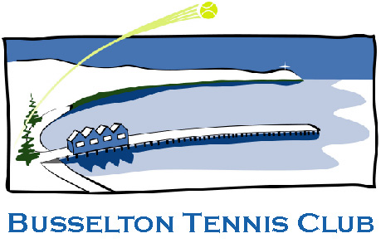

2021 Busselton Open Tournament

Tournament Dates: 27th, 28th February, 1st March 2021

Entries close: Saturday 13th February, 2021

Withdrawal deadline: Saturday 13th February, 2021

Venue: Busselton Tennis Centre

Address: 3 Carey Street, Busselton

Post Entries: Open Tournament,
40 Timbermill Crescent
Busselton 6280

Tournament Inquiries: 08 9754 3567

Tournament Director: James McGregor
btctournament@iinet.net.au

Tournament Referee: Ken Madden
kandw@bigpond.net.au

Online Entry:

https://tournaments.tennis.com.au/tournament/462B5DFD-CEF4-4102-A1AD-30D351658BBA

www.busseltontennisclub.com.au

2021 Busselton Open Tournament
TOURNAMENT NOTES AND CONDITIONS
This tournament is sanctioned by Tennis West and will be conducted under the present Rules of Tennis and the
Rules and Regulations of Tennis Australia and Tennis West. www.tennis.com.au
The committee reserves the right to order any match to be played on other than the tournament courts or under lights.
Players Please Note Play will commence at 8.00am on Saturday 27th, & 7.30am Sunday 28th & Monday 1st
Players: may enter a maximum of three (3) events. If a player is still in 3 events on the final day, they must be prepared to play to the tournament scheduled times or withdraw from one (1) event.
Competitors in senior events must be the specific age as at March 31st 2021. ( Men / 40years - Women / 40years)
Tennis attire: players should be clothed in suitable tennis attire and wear appropriate shoes. (grass court & non marking)
Entry: One entry per person to be completed. Fees are to be paid with entries and are inclusive of GST. Cheques
to be made payable to “Busselton Tennis Club” and marked “not negotiable”. Enquiries may be directed to the
Tournament Director - email: btctournament@iinet.net.au
Entries shall be limited to those received from the first 300 entries whether the closing date for entries has been reached or not. Each partner in doubles is required to submit entry form in time to be considered as accepted.
Online Entry: payment by Credit Card. Please print and retain your receipt as proof of entry and payment.
Fees can be paid directly to Busselton Tennis Club. BSB 306005 A/C 4155124 (mark: name/open)
Format:
All Championship Events best of 2 t/b sets with a match t/b at 1 set all. ( first to 10 points with a 2 point advantage).
Over 40yrs Mixed Doubles best of 2 t/b sets with a match t/b at 1 set all. ( first to 10 points with a 2 point advantage).
Round Robins and all other events to be: First to 9 games, (7 point tiebreaker at 8 all).
Code of Behaviour: The Tournament will be conducted in accordance with Tennis Australia Rules & Regulations and Code of Behaviour. Tennis Australia may penalise or suspend players for breach of the Code of Behaviour
Fees must accompany entry forms and will only be refunded if cancellation is received ten (10) days prior to commencement of event. If fees do not accompany entry form a penalty fee of $5.00 will occur.
A Player Sanction Fee of $2.50 is included in your entry fees.
More manual entry forms available at www.busseltontennisclub.com.au
Match Schedule: It is the player’s responsibility to check the draw. Players must sign in 15 minutes prior to match time. Matches will be forfeited if players are not ready to play at stipulated times. To determine the schedule for your first match please access https://tournaments.tennis.com.au/tournament/462B5DFD-CEF4-4102-A1AD-30D351658BBA
Heat Rule – When the temperature is forecast to be over 37 degrees players are still required to report to the venues
for their scheduled match time. When the temperature reaches 37 degrees and over, all matches will be suspended
and no subsequent matches will be played. When the Wet Bulb is in use to monitor humidity and temperature the referee at their discretion will suspend or postpone play.
Privacy Act: Tennis West requires the information requested on this entry. Your personal information will only be
used in accordance with the policies of Tennis West.
Publicity Clause: Photographs and results will be used to promote the tournament for publicity purposes without
compensation. Please inform the Tournament Director before the tournament commences if you do not want
your photo published.
Adjustments: The Tournament Director, on behalf of the Tournament Committee, reserves the right to reduce, reschedule or transfer to another venue, any matches as required, in the case of extenuating circumstances. The Tournament is a 3 day event and as such, matches will be played in the afternoon of Monday 2nd. Each event has been nominated a playing surface which we will try to adhere to but reserve the right to change.
Rules & Policies: You acknowledge that, as a participant in this event, you are required to comply with
various rules and policies. For more info see www.tennis.com.au

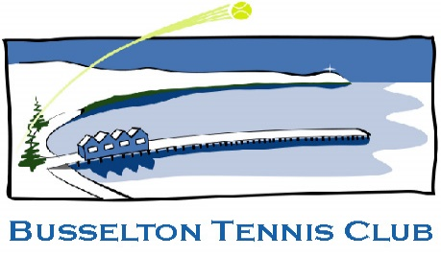
2021 Busselton Open Tournament

Name: . . ... . . . . . . . . . . . . . . . . . . . . . . . . . . . . . . . . . . . . . . . . . . . . . . . . . . . . .
Address: . . . . . . . . . . . . . . . . . . . . . . . . . . . . . . . . . . . . . . . . . . . . . . . . . . . . . . . . . . . . . . . . . . . . . . .
Post Code: . . . . . . . . . . . . Gender: M / F D.O.B. . . . . . . . . . . . . . . . . . . . . . . . . .
Affiliation Membership Club: . . . . . . . . . . . . . . . . MYTennis id # . . . . . . . . . . . . . . . . . . . . .
Level of play or rating. . . . . . . . . . . Email: . . . . . . . . . . . . . . . . . . . . . . . . . . . . . . . . . . . . . . . . . . . . . . . .
Phone: Home . . . . . . . . . . . . . . . . . . . . . . . . Mobile . . . . . . . . . . . . . . . . . . . . . . . . . . . . . . . .
One entry form per player and post to: OPEN TOURNAMENT, 40 TIMBERMILL CRES, BUSSELTON, WA 6280
by 5.00pm, 12th February 2020. BTC bank details BSB 306005 A/C 4155124 or enter online
(An entrant's nominated partner for doubles must submit a separate entry form).
Competitors may not enter more than THREE (3) events.
SPECIAL CONDITIONS
1. A player entering an event, may not enter another event in the same group.
2. All players must be prepared to play on all surfaces.
No | Event Court | Partner | Group | Cost P/P | Event  Total
1 | Men’s Championship Singles Grass | XXXXXXXXXXXXXX | 1 | $40
2 | Men’s Div.2 Singles RR Hard | XXXXXXXXXXXXXX | 1 | $40
3 | Ladies Championship Singles Grass | XXXXXXXXXXXXXX | 1 | $40
4 | Ladies Div.2 Singles RR Hard | XXXXXXXXXXXXXX | 1 | $40
5 | Men’s Championship Doubles Grass |  | 2 | $40
6 | Men`s Div 2 Doubles RR Hard |  | 2 | $40
7 | Ladies Championship Doubles Grass |  | 2 | $25
8 | Ladies Div.2 Doubles RR Hard |  | 2 | $40
 |  |  |  | $25
9 | Mixed Open Doubles Grass |  | 3 | $25
10 | Mixed Doubles Div 2 RR Hard |  | 3 | $40
11 | Over 40yrs Men`s Doubles RR Grass |  | 4 | $40
12 | Over 40yrs Ladies Doubles RR Grass |  | 4 | $40
13 | Over 40yrs Mxd Doubles 1 Grass |  | 5 | $25
14 | Over 40yrs Mxd Doubles 2 Grass |  | 5 | $25
15 | Over 40yrs Mxd Doubles 3 Grass |  | 5 | $25
 |  |  | Total

Senior Events (Men 40+ / Ladies 40+) as at 31/3/2021
Casual Dinner & Music after tennis Sat. 27th February. 7.15 - 11.30 (Pay on Day)
I CONFIRM MY ENTRIES FOR THE FOLLOWING EVENTS NOs : ........... . ............ ...........
I enclose a cheque/money order or paid online to the value of $.............. .Covering Tournament Entry
payable to Busselton Tennis Club (Inc) BSB 306005 A/C 4155124 (mark: name/open)
I agree to abide by the rules as set out in the Notes and Conditions.

Signed………...……………… ………………. Date …./…./………

Please Support our Generous Sponsors

