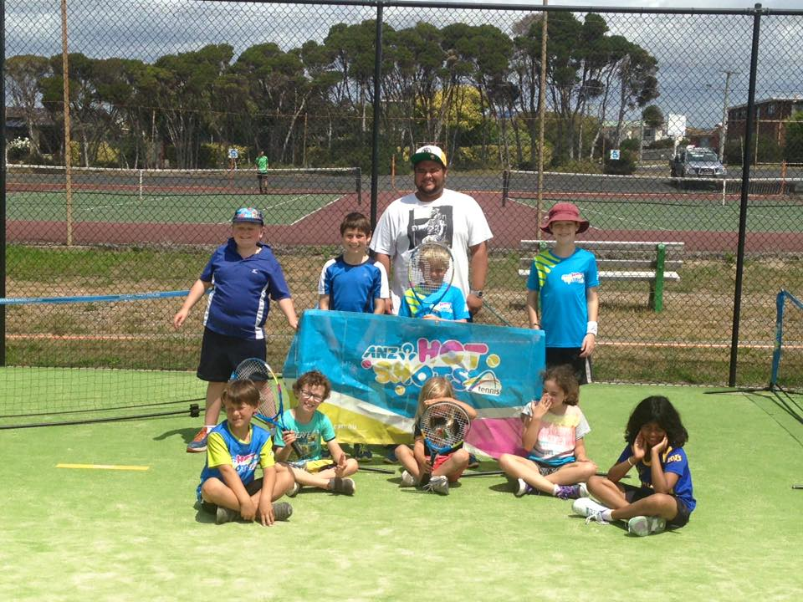

2017 Devonport Junior Winter Challenge
Entry Form
FULL COURT AND HOT SHOTS PLAYERS

Dates: Tuesday July 18th- Wednesday 19th
Venue: Devonport Tennis Club
Time: 9am till 3pm both days (Full Court)
9:30am till 3pm both days (Hot Shots)

Tournament Director: Gray Hiller
FREE SAUSAGE SIZZLE ON WEDNESDAY
CANTEEN FACILITIES AVAILABLE BOTH DAYS
How to Enter
Post to: Gray Hiller
14 Eugene Street
Devonport, 7310
Email to: ghiller@bigpond.net.au
By hand: to Gray Hiller at the Devonport Tennis
Club
ENTRIES CLOSE 5PM MONDAY JULY 17th 2017
Tournament Conditions
- The tournament shall be conducted in accordance with the laws of tennis as set by the International Tennis Federation.
- Players must be available at all times during the tournament. No time exemptions will be granted.
- All players must be 18 years or under as of January 31st 2017.
- The format used will be at the discretion of the tournament director and will depend upon entry numbers and courts available.
- Players must compete in all scheduled matches.
- Seeding will be determined by the tournament director.

Junior Hot Shots Coaching Camp
- Each day will start at 9:30am and finish at 3pm with a one-hour lunch break.
- The course will comprise all basic strokes in a modified tennis environment under the supervision of a Tennis Australia qualified coach or trainee coaches.
- All fees are payable in advance and will not be refunded except for extreme circumstances.

PLEASE NOTE: Once children have been dropped off, they will not be permitted to leave the club until being picked up. However, parents and guardians are more than welcome to stay and watch.

ENTRY FORM
Surname
First Name
Gender
Date of Birth
Email
Phone
Post Address
Medical Conditions

Events |  | Entry Fee
Full Court Classic |  | $25
Hot Shots Coaching Camp |  | $50
Hot Shots – Second Child Family Discount |  | $40
Hot Shots – Third Child Family Discount |  | $35
Total Fee

