**Understanding Wet Bulb Temperatures: How does the wet bulb rating work and how is it relevant to sporting situations?**

The key points are;

* The body always produces excess heat through metabolism
* A by-product of physical activity is heat. The greater the level of activity and at higher intensities, the more heat is produced.
* The body’s cooling processes include, perspiration, radiation and convection (movement of air across the skin)
* The higher the air temperature and humidity levels, the harder it is for the body to lose heat. You can reach the point where a combination of dry temp (actual air temp) & humidity exceed the body’s ability to lose heat and cool itself
* The body’s core temperature is roughly 37 C. The higher the core body temperature, the more stress is placed on the organs of the body, which may result in heat stress and heat stroke.

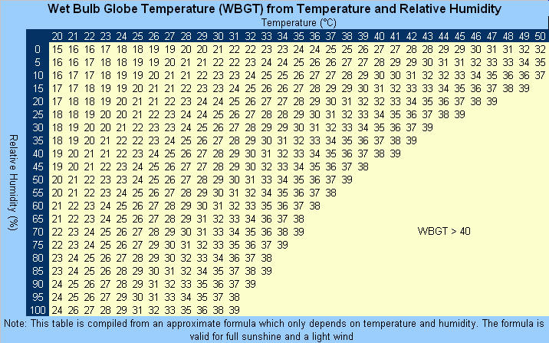

**To give you some examples, here are some days within January 2018 in Shepparton at 3pm:**

* Wednesday Jan 3rd: Temperature was 25, Relative Humidity was 36, making the WBGT 22 (roughly)
* Friday Jan 26th (Australia Day): Temperature was 36, Relative Humidity was 28, making the WBGT 31 (roughly)

[Click here](http://www.bom.gov.au/products/IDV65079.shtml) and you will find the Wet Bulb Reading for Shepparton, which the association will use as its guide.

[Click here](http://www.bom.gov.au/climate/dwo/201801/html/IDCJDW3074.201801.shtml) for the relevant data for the temperature within Shepparton in January 2018, which can be used as a guide to read to the graph. If you look at each day in January and gather the temperature and the ‘relative humidity’ (RH) you will be able to match this information, found in the graph below. *(Note: This formula is valid for full sunshine and light wind – AKA typically Country North East weather)*