How to set up your Competitive Player Profile

The SDTA uses League Manager to administer it’s competitions.
Without a CPP for each player, it is impossible for us to do so. Please sign up now.

Each player only needs to create a CPP one time.
Most sports across Australia require their players to complete a registration to participate.

Visit matchcentre.tennis.com.au and either login to your tennis account, or select “Register here” if you don’t have a tennis account.

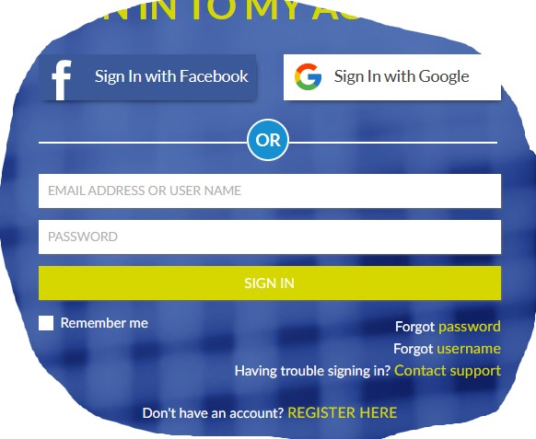

Follow the prompts to set up your tennis account and then your Universal Tennis ranking.

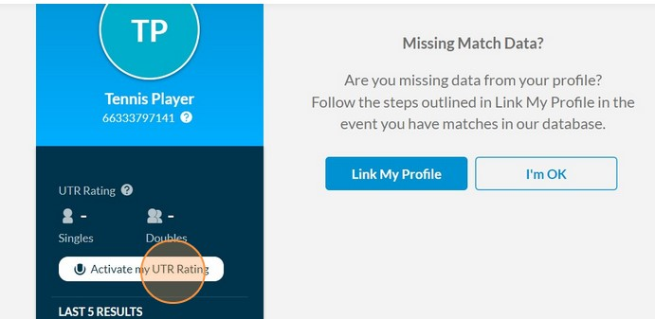

Follow the prompts to complete your Competitive Player profile.

There is also some good information at www.tennis.com.au/competitiveplay/create-your-cpp, which will also step you through the process.

