Go to tennis.com.au

Click on “JOIN”

Click on “Under 15? JOIN HERE”
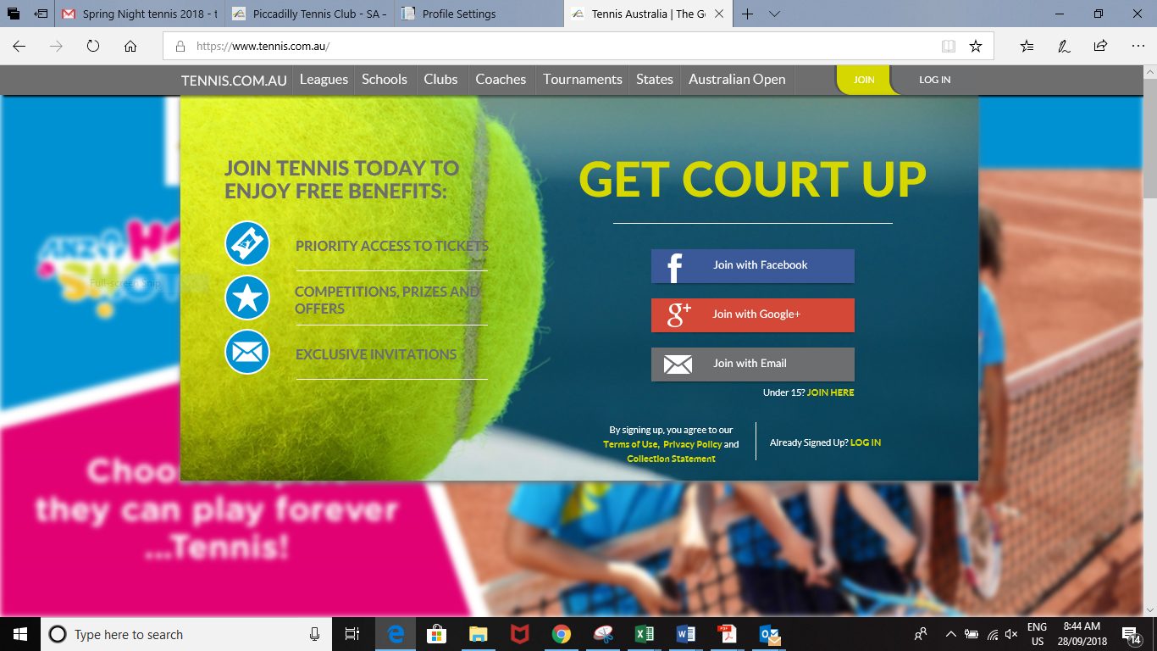

Create a new membership, which is linked to parent’s email
