

Tennis NT Board of Directors

Expression of Interest

Casual Vacancy position

Background
Tennis NT has 2 vacant Board positions. The Board has the ability to appoint Directors via the Casual Vacancy process (section 33 of the Tennis NT constitution “the constitution”).
Applicants should read section 27 of the constitution to ensure their eligibility to the Board of Directors. Some questions with the Personal Details refer to your eligibility.
Following the completion of a skills matrix across the current Directors, the following skills have been identified as being key areas of expertise that we are seeking:
• Legal;
• Commercial/tennis centre management; and
• Tennis pathway development

Applications are due by Thursday 30th April, 2026.

Meetings of the Tennis NT Board:
Regular meetings: end of February; end of May, end of August, end of November, and a meeting within the AGM (date to be confirmed).
Special meetings: on average there are an additional 3-4 meetings per year which are typically single-purpose meetings regarding budgets, risk, and other topics as required.
Directors may attend meetings in-person or join remotely from another location. In-person meetings are held at the Darwin International Tennis Centre. Meetings are held outside of office hours, typically on a weeknight and occasionally on a Saturday morning.

Key Documents:
Tennis NT Strategy: https://www.tennis.com.au/nt/about/independent-board
Tennis NT Annual Report FY2025: https://www.tennis.com.au/nt/about/annual-reports
Tennis NT Constitution: https://www.tennis.com.au/nt/files/2024/12/Tennis-NT-Constitution-Adopted-on-16.11.2024_final_publish.pdf

Applicant Questions:
- If you have questions about this application – email tennisnt@tennis.com.au
- If you have questions about the role of the Board - email President Steve Rossingh at steve.rossingh@outlook.com

Submission of your application and checklist:

Please read this document in full before starting your application.
Your completed application should include the following as one document:
  - Your completed application using the template provided in this document;
  - An email from a Member Delegate in support of your application;
  - Your CV

Email your completed application to President Steve Rossingh at steve.rossingh@outlook.com.

APPLICATION TEMPLATE

Please read this document in full before starting your application.
Notes in this colour provide context to the question and your eligibility for the position.
Highlighted notes are instructions.

Personal Details
Applicants must provide personal details to support their application and confirm eligibility:
- Your name:

- Your home address to confirm you are a resident of the NT:

- Applicants must be over 18, confirm if you are over the age of 18: (yes / no)

- Email:

- Mobile number:

- Your Linkedin (provide url):

- Membership to tennis club/s past or present (complete table below):

Tennis Clubs | Current Member (Yes / No) | Comments on Club Membership  ie, not a member but play regularly, was a member in the past, etc…
Example Club | Yes | Member since 2023

- Are you currently on the committee of any Tennis NT-affiliated clubs? (complete the table below):
Tennis NT Affiliated Clubs | Current Club Committee Representative (Yes / No) | Comments on Club Committee Positions  ie, your role: President, Vice President, Treasurer, Ordinary Member, Fundraising etc…
Alice Springs Tennis Association
Palmerston Tennis Club Incorporated Association
Gove Peninsula Tennis Club
Katherine Tennis Club
Gardens Tennis Club

- If you are currently on the committee of any of the clubs affiliated with Tennis NT (question 8), are you prepared to step-down from your club role if successful in your application to a Director position on the Tennis NT Board?: (yes / no)
Please note, stepping down from formal club committee roles is a requirement of the Tennis NT Board of Directors if you are successful in your application.

- Are you currently or formerly an employee of Tennis NT? (yes / no)
Current Tennis NT staff are ineligible for Director role. Former staff must have left Tennis NT for a period of at least 2 years before becoming eligible.

- If you answered yes to question 10, please advise the month and year you last worked for Tennis NT (note, this includes casual staff at Tennis NT, Darwin International Tennis Centre, and Gardens Tennis Club when Tennis NT was the operator): (month, year)

12: Have you been a Director on the Tennis NT Board in the past?: (yes / no)

- If you answered yes to question 12, please advise the month and year your Board tenure ended, and advise the nature of your departure:
  - Retired, reached end of tenure: (month / year when tenure ended).
  - Resigned or unsuccessful in re-appointment: (month / year when term ended).
Directors who retired from the Tennis NT Board due to reaching the end of their maximum tenure are ineligible to return until at least 3 years have passed.

Support from a Member Delegate

To support your application for a casual vacancy position, you must have the support of a current member delegate. Member delegates are Presidents of clubs affiliated with Tennis NT.
To confirm the support from a member delegate, we ask that you contact them and discuss why you are seeking to apply for this position and ask for their club’s support.
To confirm their support, the member delegate supporting your application must write an email which should be added to your application.
The member delegates are listed below:
- Gove Peninsula Tennis Club: Nicola (Nicky) Mayer govepeninsulatennisclub@gmail.com

- Katherine Tennis Club: Elisabeth (Lis) McKerracher elisabethmckerracher@gmail.com

- Palmerston Tennis Club Incorporated Association: Steve Ward steve.ward3@bigpond.com

- Gardens Tennis Club: Andrew Hawke hawkeandrew@aapt.net.au

- Alice Springs Tennis Association: Joel Crawford joelcrawford43@gmail.com

Directors Code of Conduct
The applicant must read and understand the Directors Code of Conduct and agree that they will abide by them if successful in their application.

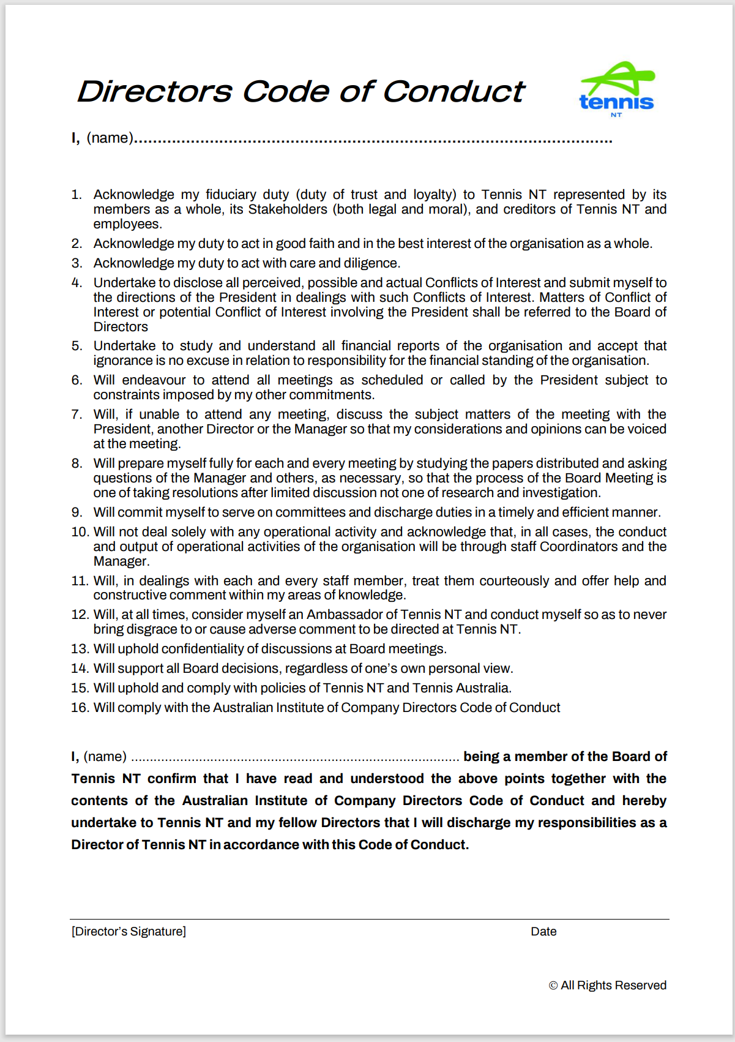

I (your name)………………………… have read the Directors Code of Conduct and agree I will abide by this code if successful in my application.
The above must be filled in to indicate your intent to abide by the code. If appointed to the Board you would then formally sign the Directors Code of Conduct.

Skills Matrix
The Tennis NT Board maintains a skills matrix to ensure that new Directors complement the existing skills of the Board.
***Skills listed against *** are key areas of expertise the Board is seeking.
Complete this skills matrix below:
Area | Experience  (Yes/No) | Comments on Experience  Volunteer or paid experience, formal qualifications, etc…
Legal***
Leadership
Corporate Governance
Strategy Development
Risk Management
Not For Profit Sector & Grant Management
Financial Management
Asset Management
Venue Management (general)
Venue Repairs & Maintenance & Upgrade
Commercial Management
Marketing
Media Management
Communications
Sponsorships (acquisition & management)
Human Resources
Advocacy
Government Relations
Tennis Specific Skills
Pathways***
Tennis Centre Management***
Club Management
Coach Development

APPENDIX

Email from a Member Delegate in support of your application

Please insert an email from a Member Delegate in support of your application

Your CV

Please include your CV in this application document.

