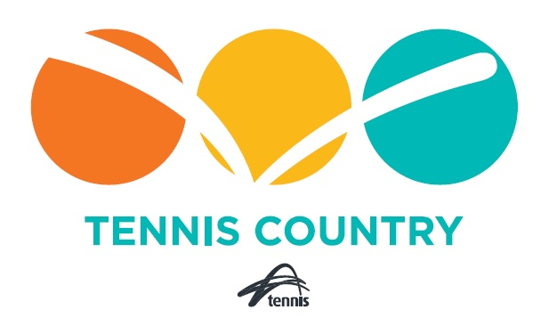

NSW TENNIS COUNTRY
REGIONAL COACH SUPPORT GRANT

GUIDELINES AND APPLICATION
2023

Contents
1.1 Program Overview and Purpose 3
1.2 Application Process 3
1.3 Eligibility criteria 3
1.4 Assessment process. 4
1.5 Notification Process 4
1.6 Acquittal Process 5
1.7 Applicant’s warranty 5
1.8 Suspension or amendments to the program 5
1.9 Privacy 5

Program Overview and Purpose
NSW Tennis Country has developed an annual grant scheme to provide financial support to regional based coaches with the purpose of assisting those coaches in developing regional based players who are active within the competition and event space.
This program will consist of ten (10) individual $1,000.00 grants to be awarded to regional coaches based on a competitive application process each year.
Each application will be assessed by a judging panel (Panel) appointed by NSW Tennis Country who will make a recommendation to Tennis Country Management Committee. The ultimate decision to award the grants will be at the absolute discretion of the Tennis Country Management Committee.
Applications for this grant will open on the 1st of April 2023 and will close on the 31st of April 2023 with the successful applicants to be notified in May of 2023.
These funds will need to be used for a purpose which is consistent with the objectives of the grant as set out below. Acceptable purposes could include the purchase of new coaching equipment, replacing or upgrading existing coaching equipment, or for use in the delivery of new coaching programs designed to help develop regional players. An outline of the intended use of the funds is required as part of the application process.
All grant funds will need to be spent within 12 months of being awarded and once spent will need to be acquitted with evidence of spending consistent with the proposed use outlined in the application process.

Application Process
Applications for this grant will open on the 1st of April 2023 and will need to be submitted in full no later than the 31st of April 2023 by email to brett.bevan@tennis.com.au.
Applicants should complete the application in full, providing as much information as possible to ensure the Panel can make an adequate assessment. Applications that are incomplete will not be considered for recommendation by the Panel to the Tennis Country Management Committee.
A copy of the application form can be found as an appendix to this document or alternatively you can contact Director of Tennis NSW and NSW Tennis Country Chair Brett Bevan via email brett.bevan@tennis.com.au to obtain a copy of the application form.

Eligibility criteria
This grant is designed to provide financial support to regional based coaches, so that they can continue to promote, grow and develop regionally based players. Essential to any coach’s ability to develop players is for that coach to be appropriately equipped and resourced.
An example of the types of items or projects this grant can be used for are below.
- New coaching equipment (Ball Tubes, Hats, Markers, Lines etc)
- Seed funding for new coaching programs.
- Funding for expansion of existing successful programs.
- Travel to events in support of high-performance players.
It is anticipated that this will be a very competitive process and coaches are encouraged to focus heavily on outlining in their applications how they will best use the funds to develop regional players.
Coaches who hold the following qualification are eligible to apply.
- Tennis Australia Coach Members actively coaching within the area defined as NSW Tennis Country and being employed or engaged by a Member of Tennis NSW.
- Coaches qualified by a third-party provider (ie: ATPCA and alike), subject to the coach being employed or engaged by a Member of Tennis NSW and actively coaching within the area defined as NSW Tennis Country and having provided a current valid WWCC and National Police Check upon lodging the application for this grant funding.
Applicants should note a full integrity and compliance check will be performed as part of the assessment process, including the verification of working with children checks where appropriate.

Assessment process.
Each grant application will be judged by the same 3-person Panel appointed by the Tennis Country Management Committee in their absolute discretion. The Panel members will be independent of all applicants.
The criteria used to assess each application will the same for each application and ultimately a recommendation will be made to the Tennis Country Management Committee by the Panel. The Tennis Country Management Committee shall make the final determination in respect of the awarding of grant funding at their absolute discretion.
For the 2023 application process, the following is an overview of the criteria being used for each Application:
- likelihood to benefit players in regional NSW;
- likelihood to benefit marginalised and otherwise disadvantaged players;
- likelihood to increase female player participation;
- applications from coaches in areas significantly disadvantaged by natural disasters over the past 3 years;
- likelihood to increase a player or players possibility of becoming semi-professional or professional;
- applications from coaches with a history of engagement, participation, and success in delivering Tennis NSW or NSW Tennis Country strategic goals;
- applications from coaches who provide services to students with a physical, intellectual, or vision-based disability;
- applications from coaches who demonstrate a genuine need for financial support and who demonstrates that without support they will be unable to continue coaching to the same extent;
- applicant’s history of supporting NSW Tennis Country programs such as RMS, Regional State League, Tennis Country Series and Regional Open and Squad Days; and
- applicant’s history and compliance with Tennis NSW child safety standards.

Notification Process
All applicants for funding will be notified in May of 2023 of the result of their application with the successful applicants being required to sign a funding agreement and submit an invoice to NSW Tennis Country in the amount approved. Funds will be released promptly upon receipt of the invoice from the successful applicants.
Successful applicants will have until the 31st of May 2024 to submit an acquittal of the funds and provide NSW Tennis Country with evidence of the expenditure of funds consistent with the objectives or purpose stated within the approved grant application.

Acquittal Process
Applicants who were successful in the 2023 round of grant funding will be required to submit a copy of the grant acquittal document along with receipts or evidence acceptable to NSW Tennis Country to demonstrate that the funds provided were use consistent with the intended purpose and consistent with the associated application.
Applicants may submit their acquittal documentation at any time up to the 31st of May 2024. If an applicant is unable to submit their acquittal documentation by this date, they must either.
- Apply to the Tennis Country Management Committee for an extension of the acquittal deadline including the reason for the extension. Any extension may be granted at the absolute discretion of the Tennis Country Management Committee.
- Return any unacquitted funds to NSW Tennis Country.
Further details on the acquittal process will be outlined in the funding agreement and the acquittal documentation which will be provided to the successful applicants.

Applicant’s warranty
By submitting an application, the applicant warrants that all information given, and each statement made by the applicant or its agents is true, correct and not misleading in any way.

Suspension or amendments to the program
Tennis NSW and/or NSW Tennis Country reserves the right to suspend, terminate or amend the terms and conditions of this grants program at the discretion of Tennis NSW. If Tennis NSW amends the terms and conditions, it will endeavour to circulate revised terms and conditions to each recipient.

Privacy
To enable us to administer the grants program, we need to collect personal information about you. When you provide this personal information, you agree that this will be used by Tennis NSW under the terms of this statement, and the tennis privacy policy located at www.tennis.com.au/privacy. That policy contains information about how you may access and seek correction of your personal information or complain about a breach of your privacy, and how we will deal with that complaint. If you do not agree, you must not provide your personal information, and you may be unable to access all of our products and services. We may disclose your personal information to other parties, including our related companies, other Australian Tennis Organisations, and third parties who provide us services.

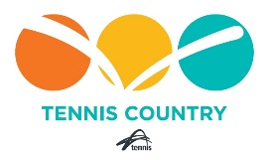
Regional Coach Support Grant
2023 Application Form.

Applicant Name: | Address:
Phone: | Email:
TNSW Affiliated Club: | Level of Qualification:
WWCC #:

- Please outline the scope or nature of the activity, project, or type of equipment you will use the grant funding for?

- How will this Activity, Project or Equipment help regional based players in NSW?

- If applicable, how will the Activity, Project or Equipment help increase female participation, Disability Participation or help regional players become semi-professional or professional.?

- Please provide a summary of your coaching experience including experience with NSW Tennis Country events such as RMS, TC Series, Regional Based tournaments, and Closed Country Champions

- Please provide any other information to the judging panel to help assess your application noting the assessment matrix’s outline in Section 1.4 of the program guidelines.

To enable us to administer the grants program, we need to collect personal information about you. When you provide this personal information, you agree that this will be used by Tennis NSW under the terms of this statement, and the tennis privacy policy located at https://www.tennis.com.au/privacy. That policy contains information about how you may access and seek correction of your personal information or complain about a breach of your privacy, and how we will deal with that complaint. If you do not agree, you must not provide your personal information, and you may be unable to access all of our products and services. We may disclose your personal information to other parties, including our related companies, other Australian Tennis Organisations, and third parties who provide us services.

