The TennisScores App
Entering Results - Authorised Users
Navigate to the required Competition/Section page….tap Results …
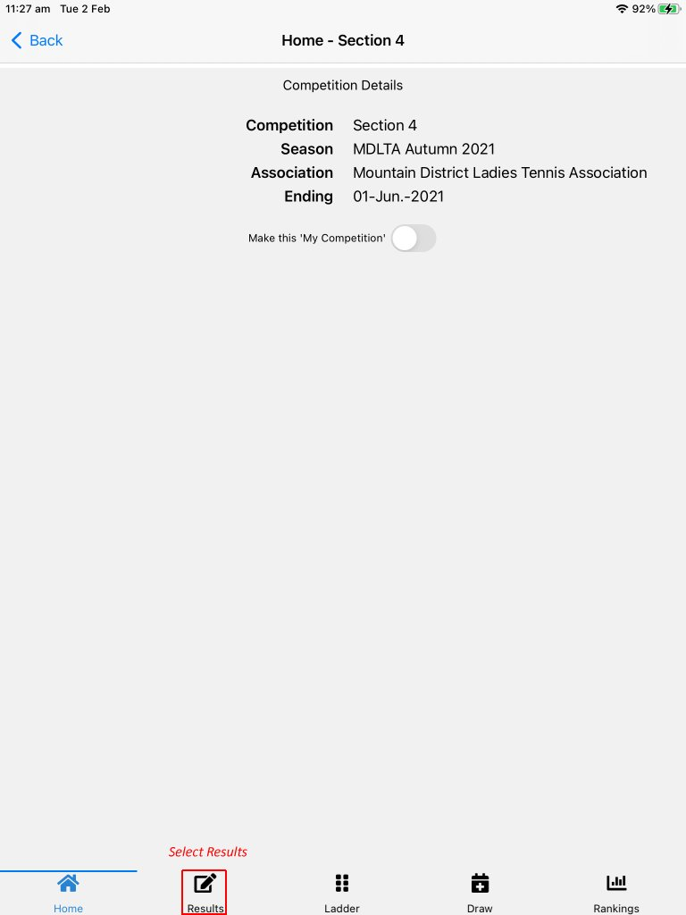
Strongly suggest new users move slider to the right ‘Show my permissions for this Competition’. Tap the header of any match to enter results….
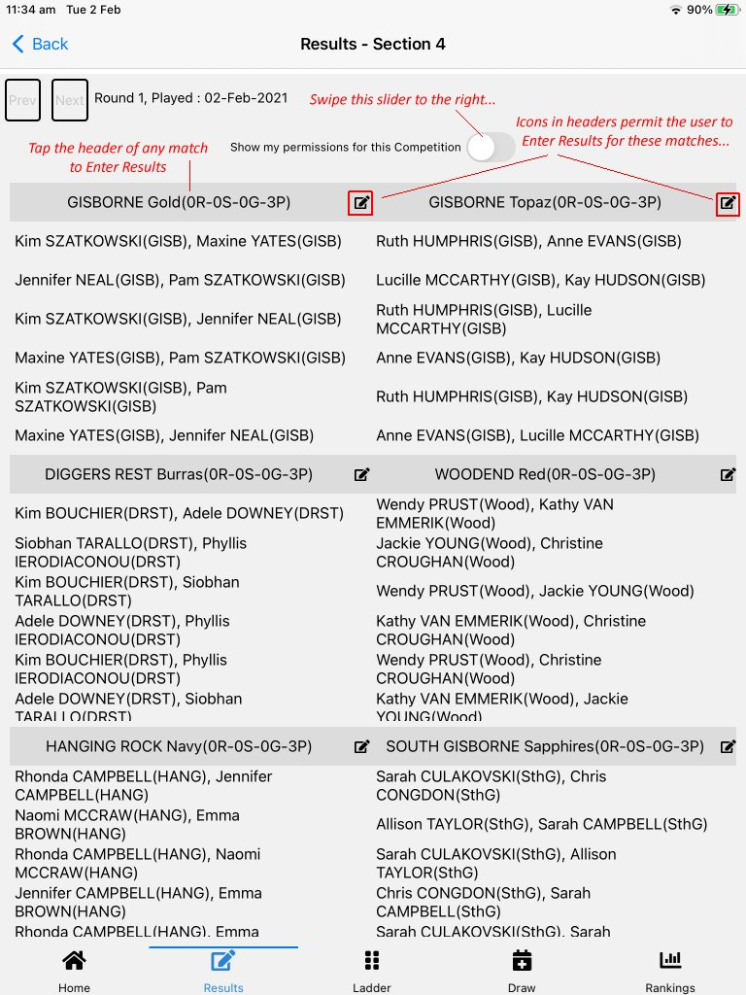

The results grid for that match appears…
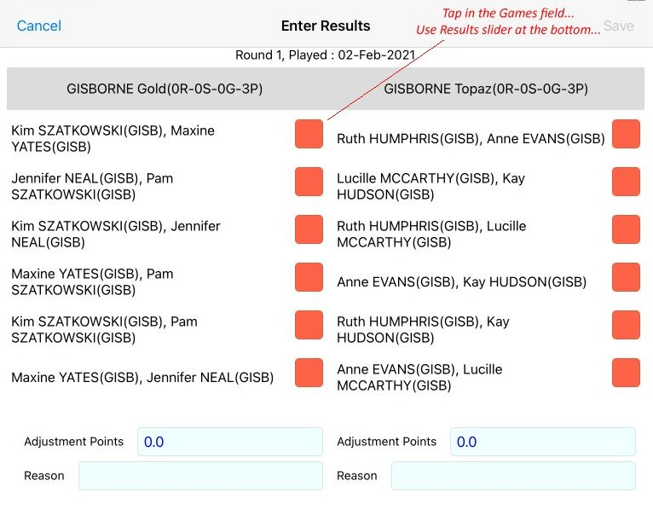
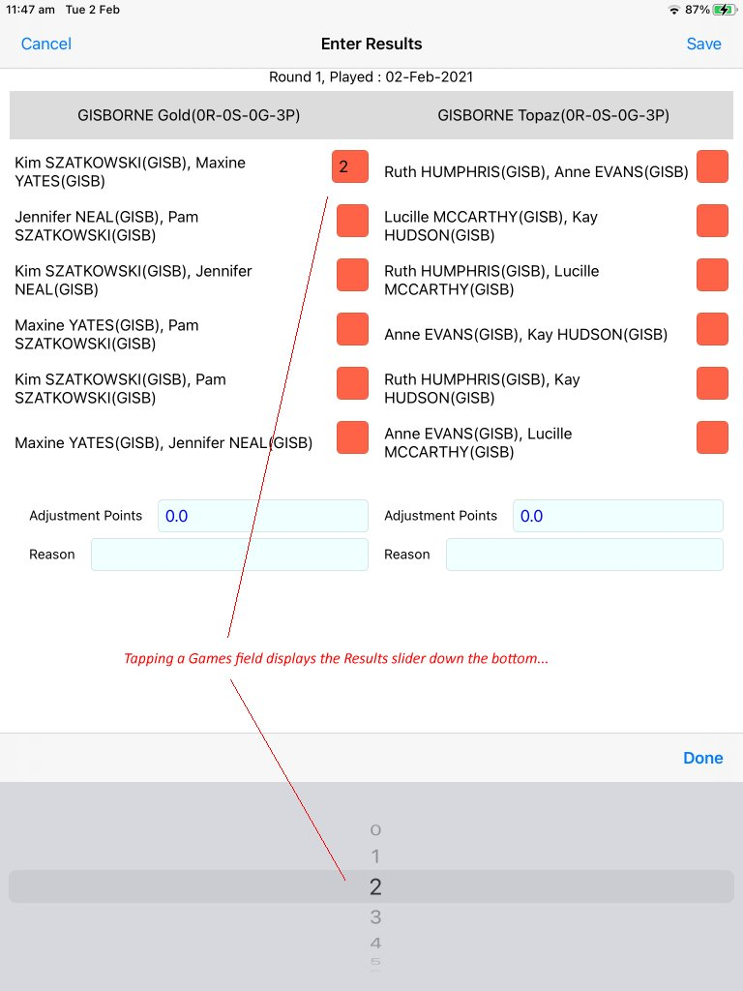

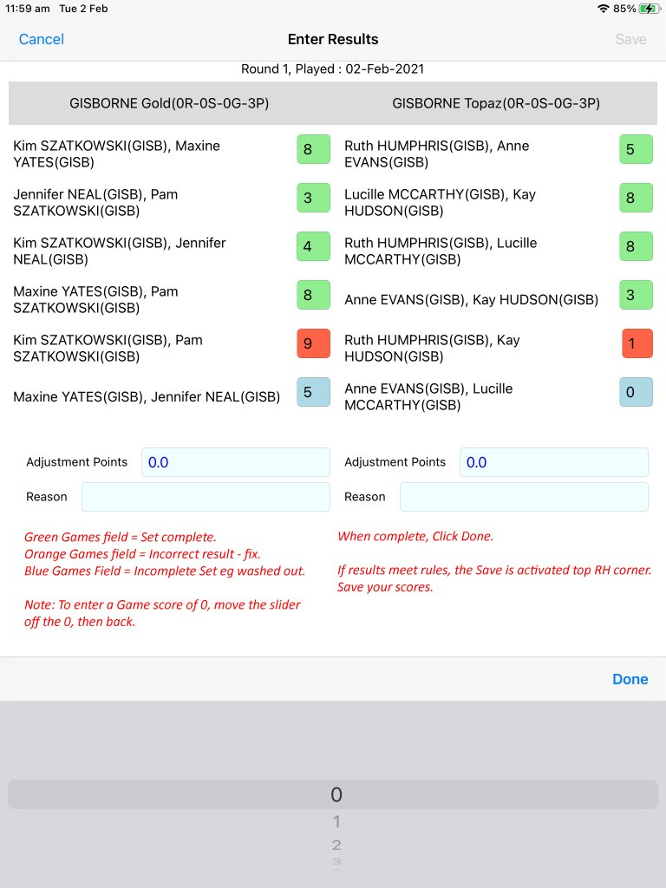

Adjusting Teams - Authorised Users
After tapping Results on the Competition page, the Results page is displayed for that competition….
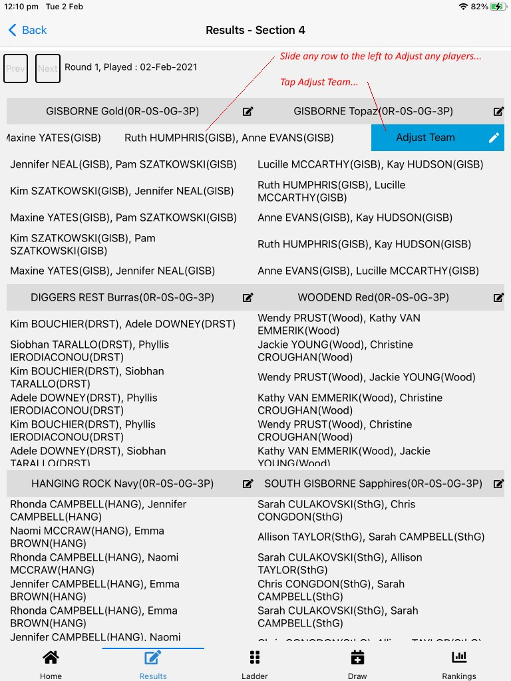

The Adjust Team page is displayed…
