Entering Results Online with tennisscores.net (mytennisadvantage.com)

The following advice is for entering match results:

You will need Internet Explorer v6 or later to manage and enter results.
Microsoft Edge is not compatible – see note 1 to enable score entry.
Safari (iMac) is not compatible – see note 2 to enable score entry.
Players can use any browser to view results.

- Click ‘LOGIN’ on the home page of tennisscores.net. Enter the login details provided to you by your club administrator. If you are unsure or your club’s login email or password, please contact the Ladder Secretary at mdltascores@gmail.com

- Click on the ‘+’ next to the section required and select the date of the current round. You will see all matches for that round but you will only be able to interact with ‘Enter Results…’ ‘0-0’ and ‘Forfeit’ buttons below the match where your team was playing at home.

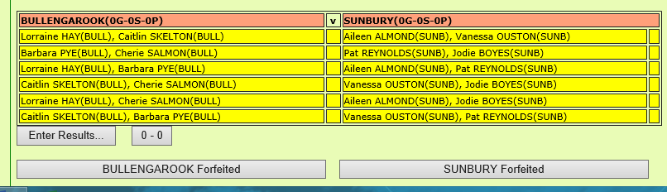

- Select ‘Enter Results…’. This will list both teams with players from the Teams page displayed. Only 4 players from each team will be displayed.

- To change players, click the button ‘Adjust Teams of the day…”.

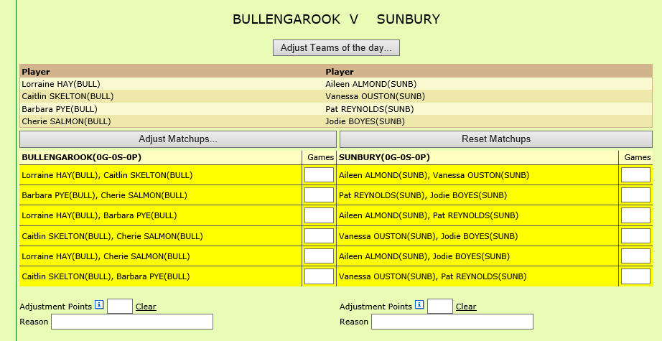

- A small, minimised blue pop-up window should appear. Expand the window’s height and width as required using the little drag arrows to be able to see the players’ names.

If the window has not popped up on the screen, check the web browser settings for this website to ensure that pop-ups are enabled.

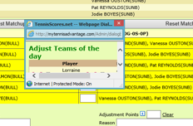

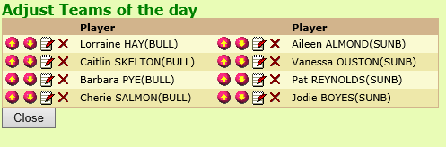

- Use the Up/Down arrows to shuffle players into the correct position.

- Use the red cross to remove a player.

- To replace a player in a position, click the notepad icon.

Enter 2-3 characters of the player’s surname. Select the required player from the drop down list and click the right arrow to display the player’s details.

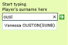

Click the tennis ball to select the player. Wait for the display to refresh and the selected player will now be displayed in that position. Close the window. Again, wait for the display to refresh.

- Enter the scores for the match and click ‘Save’ at the top of the page. Scores will be automatically totalled and points allocated.

- If a new emergency player is used and the player’s details are written at the bottom of the scoresheet, the player may not be listed. In this case results must not be entered. Forward the scoresheet to the Ladder Secretary at mdltascores@gmail.com for entry.

- In cases of unsuitable weather (complete washout or total fire ban declared) and play has been called off before any matches have started, click the ‘0-0’ button. Points will be automatically allocated.

- In the case of a forfeit, click the ‘Forfeit’ button of the team that has forfeited. Points will be automatically allocated.

The scoresheet is the responsibility of the HOME TEAM for the entering of results online by 5pm on the day following the match. The home team must forward the scoresheet to the Ladder Secretary prior to 5pm on the Wednesday following the match. Failure to comply will result in the home team being penalised 2 match points.

Note 1:

For anyone having trouble logging in to tennisscores.net from Windows 10 as Microsoft Edge is not compatible, follow these steps.

- First, check that Internet Explorer is enabled:

- Left click on Start Menu (bottom lhs of screen)
- Type “turn windows features on or off”
- Choose this item by Left clicking on this tab
- A “windows Features” window will pop up
- Make sure square check box is ticked for “Internet Explorer 11”
- Click tab “ok” to save setting

- Next step, Send Internet Explorer to your start menu or task bar:
- Left click on start menu
- Type “Internet Explorer”
- Right Click on Internet Explorer and select “pin to taskbar”
- Internet explorer will now be available to the user.

Note 2:

For anyone having trouble logging in to tennisscores.net from an iMac using Safari, you will need to temporarily change the browser to Internet Explorer v6 or later.

Before selecting LOGIN, click Develop on the Menu Bar, then User Agent and choose a version of Internet Explorer v6 or later.

