Racquet Works Junior Masters
A big thank you goes to our sponsors especially Dean at Racquet Works.
2014 has been a challenge with a number of washouts or heat outs which has meant rescheduling. I would like to thank all the organisers and players for being so accommodating. All matches were contested with excellent sportsmanship. There were also vouchers handed out throughout the competitions for players who displayed these qualities.
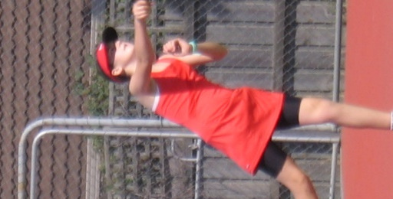
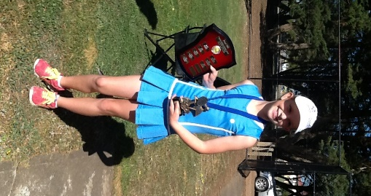
Duel 12/u
Tegan Marshall
& Jordyn Aitken

14/u
Jasmin Iaquinto

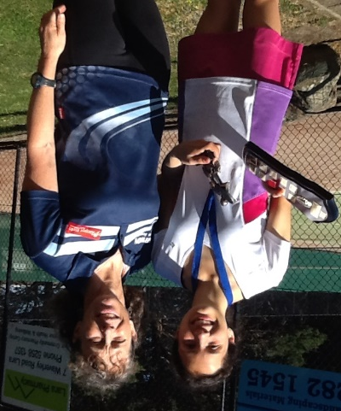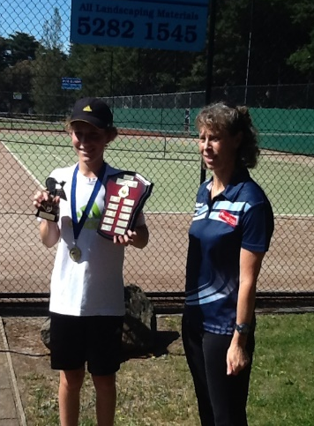
12/u Ryan Lee 16/u Catarina Saltalamacchu 14/u Zac Mirkovic

10/u Jye Bartley 16/u Jonathan Zarb 10/u Abbey McPhee

