Racquet Works Junior Masters
A big thank you goes to our sponsors especially Dean at Racquet Works.
2013 has been big. With 8 tournaments and an average of more than 40 players per tournament, this event is becoming a sort after prize for juniors throughout this region. I would like to thank all the participants for their support and good sportsmanship.

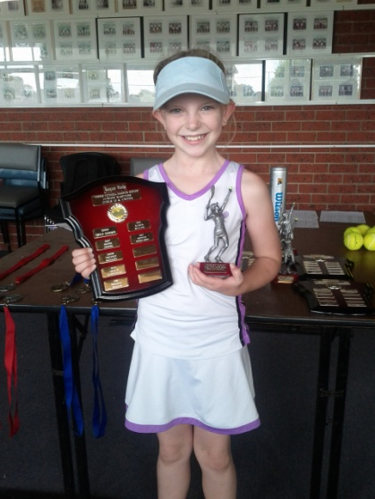
10/u Jordyn Aitken Dual 14/u Kira Aitken and Jasmin Iaquinto

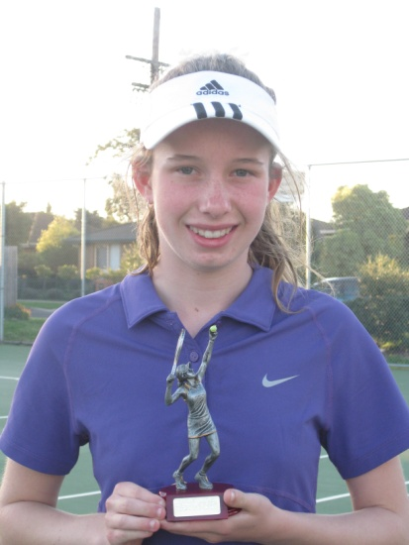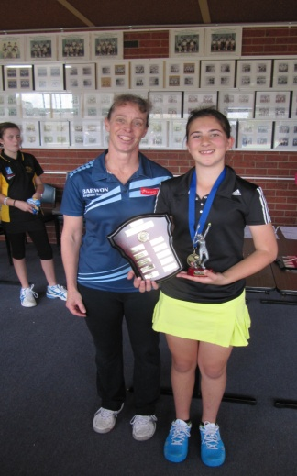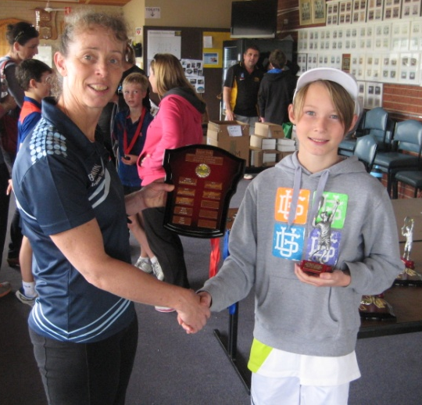
16/u Hannah Boreland 12/u Megan Markov 10/u Ryan Lee

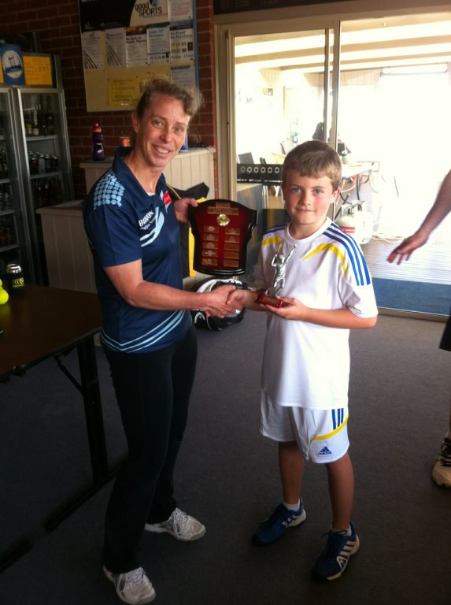
14/u Matthew Young 12/u Louis Walter 16/u Joel Wilson

