A new membership period provides a fresh opportunity for your club to review its current offerings, diversify its options, and look at innovative ways to engage with the local community. With there being no cost to register players with Tennis South Australia, this is the perfect time to modify your current offerings to get more people playing tennis at your club.

Here’s a sample of what has worked at some clubs around the state:

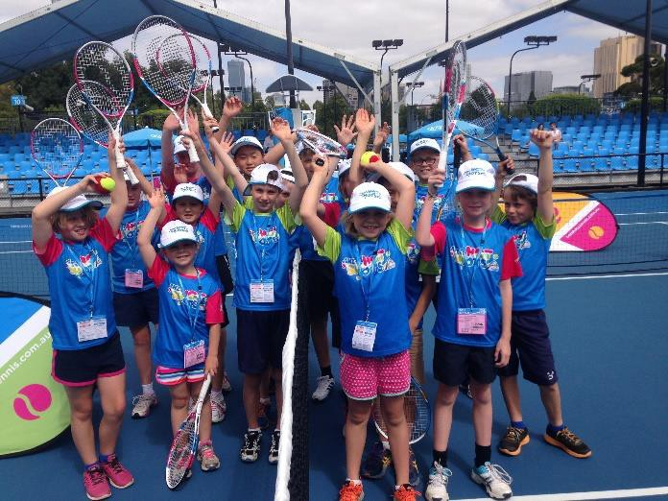
New membership types and structures…
- Coaching participant/Hot Shots membership: offer Hot Shots players, Cardio Tennis or coaching participants an introductory form of membership (in partnership with the coach). Provide the opportunity for court access before or after their coaching program so they can get more involved in the club and improve their skills further.
- Restricted family memberships: to cater for parents of children who are members or participate in coaching/Hot Shots. Gets the whole family involved where the parents are only interested in an occasional hit or purely social aspects of membership.
- Night Tennis player membership: with a small annual fee plus a pay-per play option per match, per month, or per season. Gives great flexibility to a player.
- Social/Non-playing/Support membership: Offer a non-competition focused membership for players who play rarely, just like to have a social hit, or just want to be part of the club and contribute in a small way. Also, engage parents or volunteers who don’t play tennis to still have involvement in the club to help them be more socially connected and welcome.
- ‘Rolling’ or pro-rata membership: a player who joins today is a member of the club for the next 12 months, regardless of membership periods or expiry dates. Alternatively, offer a discounted price to members who join later in the membership period, rather than charging a full year’s fee.

Different Playing Opportunities = Increased involvement at the club…
- Twilight/Night Tennis using the shortened FAST 4 format on a weeknight provides your local community with an alternative playing opportunity to traditional Saturday tennis. Ensure your competition ends at a suitable time so that people can socialise in the clubhouse after their game and look to offer food and drinks if possible.
Visit tennis.com.au/learn/ways-to-play/fast4 for more info
- Hot Shots Community Play program provides a playing opportunity for kids to learn some basic skills in a fun, friendly, family-focused ‘play session’ for kids. The session also encourages social connection with parents and volunteers to help out on the court or off the court with a bbq or kiosk.
- Hot Shots Leagues offer an opportunity for kids to put their skills to the test in a fun and social way, whilst learning the basics of scoring and game play. There are two league levels to choose from – orange ball and green ball.
Visit hotshots.tennis.com.au for more info
- Cardio Tennis is an exciting new, fun, social, fitness-focused, group tennis program from Tennis Australia that your qualified club coach can deliver to engage new or existing players in a short sharp session for all abilities. Talk with your coach to value add one free session per month or year for each member.
Visit cardiotennis.com.au for more info

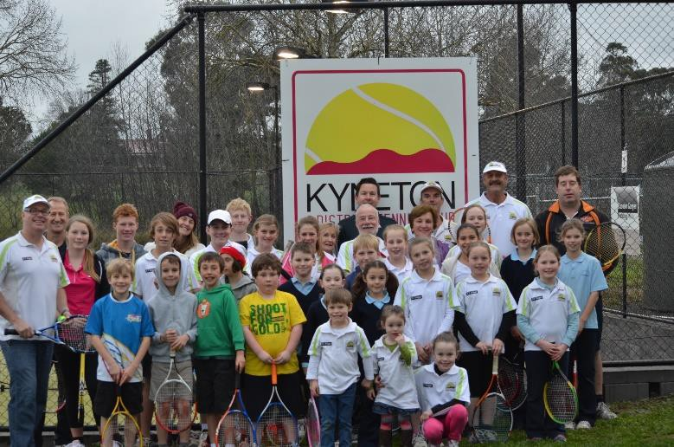
Introductory offers and promotions…
  - Run a club open day/registration day/family fun day promoted to the local community to get people at your club and offer them opportunities to play beyond the day or join up. Talk to your Participation Leader to get support for your day!
  - Add on a few months ‘for free’ for members who join just before the start of a new membership period e.g. Pay for 12 months membership, get 15 months included.
  - Offer an ‘early bird’ membership rate for signing up early, say one month before the start of financial year or season.
- Run promotions/advertisements for coaching, membership, junior tournaments and open days in
school newsletters or at schools clinics to link kids (and their parents) to their local community club.

Communications…
- Start a free club website from Tennis SA to better communicate to local community and members with latest club news, events, fixtures/results, membership and contact information.
- Start up a club Facebook page to allow your players to ‘like’ and become more aware of latest news, events and be able to create social connection with photos, comments and web links to key information. It’s the new form of the club newsletter. Maybe even try ‘Twitter’ or ‘Instagram’. Try to engage the youth of your club to run with this.
- Send a quarterly e-newsletter via MyTennis to communicate the latest news and events to your members and players. You can use the My Tennis membership system to send emails to your club membership/player database. Link news items and attachments to your club’s website. Save time and paper, go online with your club’s newsletter!
- Create a club communication register with the email addresses of social members, parents of children who receive coaching and past members to keep them informed on club news and events.

‘Sell more than just tennis’ with supporter packages and member value adds…
- Add club merchandise such as a hat, drink bottle or polo to non-playing members, kids or family membership packages as inclusive of or as upgrades to increase alternative revenue.
- Add non-tennis items such as ‘invite to annual club social event’ or ‘sponsors offer card or vouchers’ to membership package benefits so players can see more value in the membership.
- Add a key or swipe card at an additional fee to access courts so members can ‘play anytime.’

For more information or to discuss these opportunities in greater detail, contact Tennis SA on 7224 8100.

